Big Mountain Resort is a ski resort located in Montana. Annually, the resort hosts about 350,000 people for skiing or snowboarding. On average these visitors will ski for five days. The Resort has recently installed an additional chair lift, increasing their operating costs by $1,540,000 this season. The resort has been basing their ticket prices on the market average plus a premium. This pricing strategy fails to capitalize on some of the facilities that skiers value more than others. Basing the pricing in this way does not provide the business with a good sense of how important some features are compared to others. This hinders investment strategy. In light of this, Big Mountain Resort is looking for guidance on how to select a better value for their ticket price. The resort is also considering scenarios for cutting costs without undermining the ticket price or will support an even higher ticket price.

Among the considerations:

1. Permanently close down up to 10 of the least used runs.

2. Increase vertical drop by adding a run to a point 150 ft lower down. This requires the addition of another chair lift, without snow making coverage.

3. Increase vertical drop by adding a run to a point 150 ft lower down, adding another chair lift and adding 2 acres of snow making cover.

4. Increase the longest run by 0.2 miles to 3.5 miles total length. This requires an additional snow making coverage of 4 acres.

All of these scenarios were modeled with a focus on the predicted ticket price change after each of the above considerations.

**Scenario 1** – close up to 10 of the least used runs.

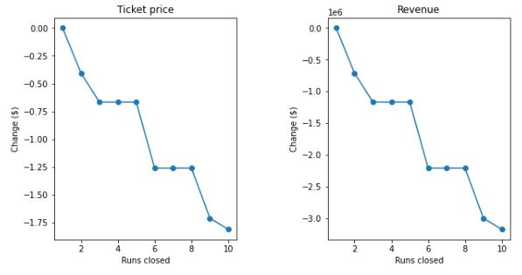

The model indicates that closing one run makes no difference on ticket price. Closing 2 or 3 reduces support for ticket price and therefore decreases revenue. Closing 3, 4, or 5 runs has the same affect. Closing 6 or more runs leads to a large drop in revenue and support for ticket price increases.

**Scenario 2** – Increase vertical drop, add a run, and add an additional chair lift.

This scenario increases support for ticket price by $8.61. Over the season, this equates to an additional $15,065,471 in revenue.

**Scenario 3** – Same as above but with 2 acres of snow making coverage.

This scenario increase support for ticket price by $9.90. Over the season, this equates to an additional $17,322,717 in revenue.

**Scenario 4** – increasing the longest run by 0.2 miles with 4 acres of snow making coverage.

This scenario has no affect on ticket price.

Linear modeling shows that vertical drop is the feature that skiers value most. Second to that is snow making coverage. People like guaranteed skiing. Random forest model of the best features are in line with this as well.

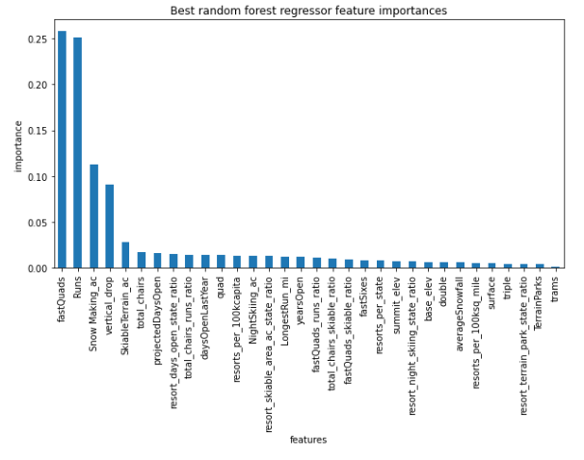

**Recommendations**

The modeling shows ticket price can be increased if Big Mountain Resort increases its vertical drop by 150 ft, adds an additional chair lift to bring skiers back up, and offers an extra 2 acres of snow making coverage. This increases support for higher ticket price by 12.22% from $81 to $90.90.

The modeling also shows that operating costs can be reduced by closing one of the least used runs. This has no affect on ticket price support.